Wrekinsport CC Open 10 Mile Time Trial

www.wrekinsport.org.uk

Result of the event held on the D10/23 on 22nd August, 2020

Promoted for and on behalf of Cycling Time Trials under their
rules and regulations

Officials

Timekeeper: Jenny York, Mid Shropshire Wheelers
Asst Timekeeper: Dave Goring, Wrekinsport CC
Recorder: Dave York, Mid Shropshire Wheelers
Event Secretary: Dave Moore, 38 Oakfield Park, Much Wenlock TF13 6HH

Prize Winners

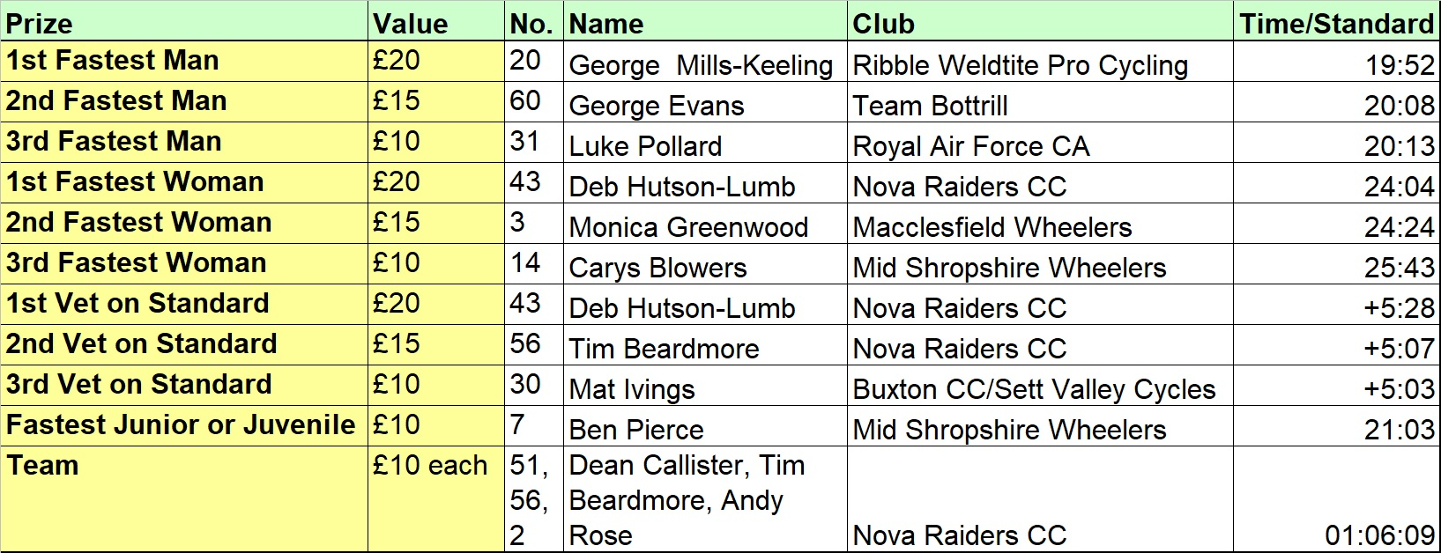

Organisers’ thanks

Thanks to Dave and Jenny for time keeping, and also to those who helped marshal, push off, record, and generally help.

Friction and Hydraulic Services Shropshire Championship
Points Series

This race was Round 3 of the Friction and Hydraulic Services Shropshire Championship Points Series run by the Shropshire Cycling Clubs Association and its member clubs. For more details, including a race report see the SCCA website at shropshirecca.uk/ and to keep up to date see SCCA Twitter at https://twitter.com/shropshirecca.

Official Result

Pos'n | Forename | Surname | Club | Cat | Time | Vet +/-
1 | George | Mills-Keeling | Ribble Weldtite Pro Cycling | S | 19:52
2 | George | Evans | Team Bottrill | S | 20:08
3 | Luke | Pollard | Royal Air Force CA | S | 20:13
4 | Kieran | Morris | Team Bottrill | S | 20:42
5 | Ben | Pierce | Mid Shropshire Wheelers | J | 21:03
6 | Grant | Bigham | VeloRunner RT | S | 21:04
7 | Henri | Bedford | Revolutions Racing | J | 21:12
8 | Danny Glyn | Roberts | Clwb Beicio Egni/Energy CC | S | 21:13
9 | Mathew | Roberts | Clwb Beicio Egni/Energy CC | S | 21:22
10 | Josh | Whitehead | Cycle Club Bridgnorth RWG | S | 21:23
11 | Dean | Callister | Nova Raiders CC | S | 21:25
12 | Mat | Ivings | Buxton CC/Sett Valley Cycles | V | 21:33 | +5:03
12 | Tim | Beardmore | Nova Raiders CC | V | 21:33 | +5:07
14 | Daniel | Watts | Royal Air Force CA | S | 21:35
15 | Matthew | Cooper | Stourbridge Velo | S | 21:37
16 | Christopher | Halford | Wrekinsport CC | V | 21:39 | +5:01
17 | Stephen | Feeney | Team Chronomaster | V | 21:46 | +4:50
18 | Ben | Bright | Marsh Tracks Race Team | J | 21:47
19 | Jonathan | Mills-Keeling | Cycle Club Bridgnorth RWG | V | 22:05 | +4:31
20 | Tomos | Hales | Wrekinsport CC | S | 22:29
21 | Ciaran | Pickering | Team Sportslab | V | 22:34 | +3:38
22 | Steve | Aston | Wrexham RC | V | 22:37 | +3:40
23 | Andrew | Rose | Nova Raiders CC | V | 23:11 | +3:47
24 | Dean | Dovey | Nova Raiders CC | V | 23:29 | +3:43
25 | Adam | Mumford | Wrekinsport CC | S | 23:48
26 | Mark | Pritchard | Nova Raiders CC | S | 24:03
27 | Deb | Hutson-Lumb | Nova Raiders CC | WV | 24:04 | +5:28
28 | Rich | Smith | Wrekinsport CC | V | 24:10 | +2:53
29 | Graeme | Donnell | Nova Raiders CC | V | 24:24 | +2:48
29 | Monica | Greenwood | Macclesfield Wheelers | W | 24:24
31 | Ian | Connolly | Ludlow CC | V | 24:33 | +2:21
32 | Rob | Jackson | Wrekinsport CC | V | 24:33 | +2:44
33 | Richard | Howes | Wrekinsport CC | V | 24:36 | +2:09
34 | Allan | Henderson | Wrekinsport CC | S | 24:37
35 | Oliver | Rodwell | Wrekinsport CC | V | 24:44 | +1:18
36 | Dave | Moore | Wrekinsport CC | V | 24:44 | +2:33
37 | Mike | Bigwood | Wrekinsport CC | S | 25:06
38 | John | Robertson | Wrekinsport CC | V | 25:14 | +2:59
39 | Phil | Guy | North Shropshire Wheelers | V | 25:23 | +3:57
40 | terry | Icke | Velo Club St Raphael | V | 25:25
41 | Peter | Mulloy | Wrekinsport CC | V | 25:33 | +2:19
42 | Carys | Blowers | Mid Shropshire Wheelers | WJ | 25:43
43 | Andrew | Clarke | North Shropshire Wheelers | V | 26:06 | +1:39
44 | Philip | Gardner | Mid Shropshire Wheelers | V | 26:26 | +0:32
45 | Richard | Goddard | Newport (Shropshire) CC | V | 26:40 | +0:37
46 | Cerys | Greaves | Team HUUB | WJ | 26:46
47 | Gail | Lowe | Niteriders | WV | 27:05 | +2:06
48 | Eleanor | Turton | Seamons CC | W | 27:14
49 | Geoff | Edgerton | North Shropshire Wheelers | V | 27:23 | +1:57
50 | Louise | Hurdley | Hafren CC | WV | 27:24 | +0:56
50 | Bethan | Till | Wrekinsport CC | W | 27:24
52 | Helen | Tudor | Oswestry Paragon CC | WV | 28:28 | +0:43
53 | Alison | Salthouse | Wrekinsport CC | WV | 31:36 | -1:34
54 | Clare | O'Donnell | Wrekinsport CC | WV | 34:13 | -5:02
. | Tony | Harvey | Mid Shropshire Wheelers | V | DNF
. | Les | Boughey | North Shropshire Wheelers | V | DNS
. | Joe | Cosgrove | Liverpool Century CA | J | DNS
. | Keri | Parton | Pro Vision Cycle Clothing | W | DNS
. | Robin | Shedden | Wrekinsport CC | V | DNS
. | Alex | Leek | PDQ Cycle Coaching | S | DNS

Upcoming Club Events

Wrekinsport CC are running club events throughout the closed season, enter from four days prior to each event via the club’s calendar section: https://wrekinsport.org.uk/events-calendar

Date | Day | Distance | Course | Comments | Series | Start Time
26/08/20 | Wed | 1 | D0/14 | Come and Try It. Hill climb | Hill Climb Series | 6.30pm
29/08/20 | Sat | 18 | D18/4 | Come and Try It | Gordon Davies H/cap. SB Series | 3:00pm
02/09/20 | Wed | 5 | D5/5 | Come and Try It |  | 6.30pm
10/10/20 | Sat | 10 | D7/10 | Come and Try It | Wrekinsport Winter Warmer R1 | 2:00pm
07/11/20 | Sat | 10 | D7/10 | Come and Try It | Wrekinsport Winter Warmer R2 | 2:00pm
05/12/20 | Sat | 10 | D7/10 | Come and Try It | Wrekinsport Winter Warmer R3 | 2:00pm
02/01/21 | Sat | 10 | D7/10 | Come and Try It | Wrekinsport Winter Warmer R4 | 2:00pm
06/02/21 | Sat | 10 | D7/10 | Come and Try It | Wrekinsport Winter Warmer R5 | 2:00pm
13/03/21 | Sat | 10 | D7/10 | Come and Try It | Wrekinsport Winter Warmer R6 | 2:00pm

